**PRELIMINARY REVIEW COPY**

Technical Report Documentation Page

|  |  |  |  |  |  |  |
| --- | --- | --- | --- | --- | --- | --- |
| 1. Report No.  FHWA/TX-xx/x-xxxx-x [Those two green digits correspond to the fiscal year in which the report is submitted] | | 2. Government Accession No. | | 3. Recipient’s Catalog No. | | |
| 4. Title and Subtitle  Lorem ipsum dolor sit amet [Report title must be different from the project title, even if by only one word.] | | | | 5. Report Date  Submitted: Month Year [put the month/year you sent it to RTI] | | |
| 6. Performing Organization Code | | |
| 7. Author(s)  Enter author names. **After each author name, enter ORCID (http://orcid.org) URL, when available**. Example: Josiah Carberry, Ph.D. http://orcid.org/0000-0002-1825-0097 | | | | 8. Performing Organization Report No.  x-xxxx-x [Example: 0-6920-1] | | |
| 9. Performing Organization Name and Address  Center for Transportation Research The University of Texas at Austin 3925 W. Braker Lane, 4th Floor Austin, TX 78759 | | | | 10. Work Unit No. (TRAIS) | | |
| 11. Contract or Grant No.  x-xxxx [Example: 0-6920] | | |
| 12. Sponsoring Agency Name and Address  Texas Department of Transportation Research and Technology Implementation Division P.O. Box 5080 Austin, TX 78763-5080 | | | | 13. Type of Report and Period Covered  Technical Report  Month Year – Month Year [The period (dates) when research was conducted; e.g., September 2014–August 2015] | | |
| 14. Sponsoring Agency Code | | |
| 15. Supplementary Notes  Project performed in cooperation with the Texas Department of Transportation. | | | | | | |
| 16. Abstract  Enter a brief factual summary of the most significant information, including the purpose, methods, results, and conclusions of the work. When appropriate, the abstract should include advice on how the results of the research can be used. **For guidance, please see ANSI/NISO Z39.14-1997 (R2015) Guidelines for Abstracts (**[**http://www.niso.org/apps/group_public/project/details.php?project_id=124**](http://www.niso.org/apps/group_public/project/details.php?project_id=124)**)**. | | | | | | |
| 17. Key Words  Enter words, terms, or phrases that identify important topics in the report. **When possible, select terms from the Transportation Research Thesaurus (**[**http://trt.trb.org**](http://trt.trb.org)**).** Feel free to include terms not found in the TRT as well, though**.** | | | 18. Distribution Statement  No restrictions. This document is available to the public through the National Technical Information Service, Springfield, Virginia 22161; www.ntis.gov. | | | |
| 19. Security Classif. (of report)  Unclassified | 20. Security Classif. (of this page)  Unclassified | | | | 21. No. of pages  TBD | 22. Price |

Form DOT F 1700.7 (8-72) Reproduction of completed page authorized

Look for blue-highlighted text throughout this document for instructions. Once you’ve filled in everything (especially the yellow-highlighted info), you can delete any blue-highlighted text. We’ve used *Lorem Ipsum* text as placeholders.



[Report title must be different from the project title, even if by only one word.]

**Report Title**

[List all authors here]

Author

Author

Author

CTR Technical Report: x-xxxx-x

Report Date: Submitted: Month Year [put the month/year you sent it to RTI]

Project: x-xxxx

Project Title: Lorem ipsum dolor sit amet

Sponsoring Agency: Texas Department of Transportation

Performing Agency: Center for Transportation Research at The University of Texas at Austin

Project performed in cooperation with the Texas Department of Transportation and the Federal Highway Administration.

Center for Transportation Research

The University of Texas at Austin

3925 W. Braker Lane, 4th floor

Austin, TX 78759

http://ctr.utexas.edu/

Disclaimers

**Author’s Disclaimer**: The contents of this report reflect the views of the authors, who are responsible for the facts and the accuracy of the data presented herein. The contents do not necessarily reflect the official view or policies of the Federal Highway Administration or the Texas Department of Transportation (TxDOT). This report does not constitute a standard, specification, or regulation.

**Patent Disclaimer**: There was no invention or discovery conceived or first actually reduced to practice in the course of or under this contract, including any art, method, process, machine manufacture, design or composition of matter, or any new useful improvement thereof, or any variety of plant, which is or may be patentable under the patent laws of the United States of America or any foreign country.

Engineering Disclaimer

NOT INTENDED FOR CONSTRUCTION, BIDDING, OR PERMIT PURPOSES.

[If your RS is a PE, use this:]

Project Engineer: Lorem Ipsem

Professional Engineer License State and Number: Texas No. xxxxx

P.E. Designation: Research Supervisor

[If your RS is NOT a PE, use this:]

Research Supervisor: Lorem Ipsem

Acknowledgments

Lorem ipsum dolor sit amet, consectetur adipiscing elit, sed do eiusmod tempor incididunt ut labore et dolore magna aliqua. Ut enim ad minim veniam, quis nostrud exercitation ullamco laboris nisi ut aliquip ex ea commodo consequat. Duis aute irure dolor in reprehenderit in voluptate velit esse cillum dolore eu fugiat nulla pariatur. Excepteur sint occaecat cupidatat non proident, sunt in culpa qui officia deserunt mollit anim id est laborum.

[Example: “The authors express appreciation to....” Acknowledgments should include the TxDOT Project Director, members of the Project Monitoring Committee and their locations (TxDOT district / division / office, or other), and any others instrumental to the project.]

Products

**[If this report contains any products**, please use this space to indicate the name of the product(s) and where it (or they) can be found in the report. If the report contains no products, you may delete this section.]

Table of Contents

Chapter 1. Welcome 1

1.1. How to Use Styles 1

1.1.1. Finding the Styles 1

1.2. How to Automate Caption Numbering and Cross-References 2

1.2.1. Using the “Insert Caption” Function 2

1.2.2. Using the “Cross-Reference” Function 2

1.2.3. Applying Automation to Table Titles Too 3

1.3. Styles Used in This Template 5

1.4. Margins and Such 6

1.5. Need Help? 6

Chapter 2. Heading 1 7

2.1. Heading 2 7

2.1.1. Heading 3 7

2.2. Heading 2 8

2.3. Back Matter Styles 9

Chapter 3. Get Your Work Read 10

3.1. Know and Use Your ORCID ID 10

References 11

Appendix A. Landscape Example 12

Appendix B. Portrait Example 13

[**A word on styles:** The table of contents and the lists of figures and tables are auto-populated (and thus can be automatically updated) through use of Word styles. We call out the style names used in this document, so you can make sure your TOC/lists are automated—and also create a uniform look across CTR publications.]

List of Tables

Table 1.1 Here's a sample table. 6

Table 2.1 ctr table title 6

Figure A.1 Here’s another sample figure. 6

List of Figures

Figure 1.1 The Styles group on the Home tab 1

Figure 1.2 The caption creation dialog box 2

Figure 1.3 The cross-reference dialog box 3

Figure 1.4 The print dialog box—escape hatch in the top left corner 4

Figure 1.5 Example figure caption 5

Figure 2.1 ctr figure caption 7

Table B1. Another sample table 13

[If you’ve applied the template styles, you can right-click in these lists to automatically update the page numbers or the entire list itself.]

# Welcome

Welcome to the CTR Research Report Template. This template provides a simple structure for writing and formatting research reports, using Microsoft Word styles. You will find contact information for help with this template at the end of this chapter. Chapter 2 illustrates styles used in the report template. You’ll notice that our body text is set to provide spacing between paragraphs (so you don’t need to use a hard return between paragraphs).

Note that the chapter number and title are on the same line. This makes our job a little easier when we are inserting metadata and bookmarks into the PDFs prior to your report’s online publication. Metadata makes it easier for people to find your work online (search engines pull from PDF metadata) and bookmarks make it easier for people to find what they are looking for within your work.

## How to Use Styles

Microsoft Word “styles” are different types of formatting (font type and size, line spacing, justification, etc.) saved and named so that you may easily apply the same type of formatting throughout a document. The following sections describe how to access and use styles in Word 2010 and beyond.

### Finding the Styles

To apply styles to your text, go to the Styles group on the Home tab. You can quickly apply a style from the gallery of styles—just select the text you’d like to apply a style to, and click on the style name. To see a complete list of the available styles in your document, click the Styles Dialog Box Launcher by hitting the little arrow in the bottom right corner of the Styles group (circled in red in Figure 1.1).

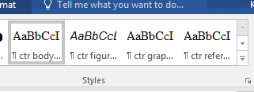

Figure 1.1 The Styles group on the Home tab

## How to Automate Caption Numbering and Cross-References

### Using the “Insert Caption” Function

To get the auto-numbering on the figure caption, by the way, select the graphic and go to the References tab, where you’ll hit “Insert Caption” (as Figure 1.2 shows). In the “Caption:” box will appear the item type and number (such as Figure 1.1); you just go ahead and type in your caption in that box and hit OK. Once the caption appears below your figure, please style it with “ctr figure caption.”

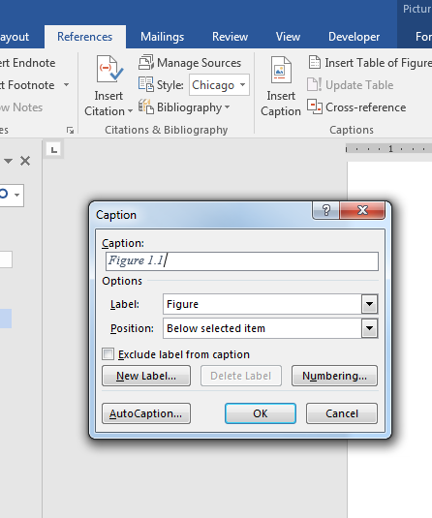

Figure 1.2 The caption creation dialog box

### Using the “Cross-Reference” Function

If you’d like, you can insert an auto-updating figure or table number in your text. This is handy if you are adding/removing tables and want your in-text references to match up with your new table and figure numbers (without having to manually update them). Just position your cursor where you want the figure number to go, then go back to the References tab and hit “Cross-reference” to arrive at the dialog box shown in Figure 1.3. Make your selections from the reference type box and set the “Insert reference to:” field to “Only label and number.” Hit OK and you’ll see the cross-reference content pop up in your text.

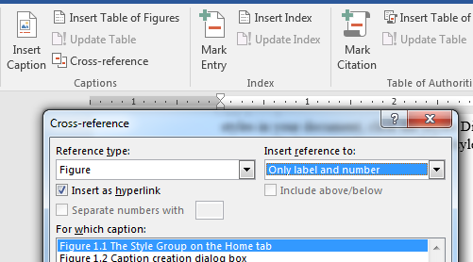

Figure 1.3 The cross-reference dialog box

### Applying Automation to Table Titles Too

All the tips about creating automated captions and cross-references for figures go for tables titles and cross-references as well. Note that Table 1.1 is just a sample—you don’t have the make your tables match that style or appearance. Remember: once the title appears above your table, please style it with “ctr table title.”

Table 1.1 Here's a sample table.

|  |  |  |
| --- | --- | --- |
| **Variable** | **Coeff.** | **t-stat** |
| Constant | -6.116 | -0.83 |
| *GDPt,t-1* | 1.151 | 2.14 |
| *Dlinesq,t-Dlinesq,t-1* | -0.670 | -2.32 |
| *RPSt* | 10.623 | 2.27 |

#### Updating the Auto-Numbering

Here’s a quick way to make your in-text references updates themselves if you have moved or deleted your figures and tables: you can hit Ctrl A + F9. This updates all the updateable fields in your document. You’ll notice that if you go to print without having updated your fields (Ctrl + P), Word will automatically update them. In fact, Ctrl + P is a smoother update—but you don’t have to actually print! You can just back out of that screen using that arrow in the top left corner, circled in Figure 1.4.

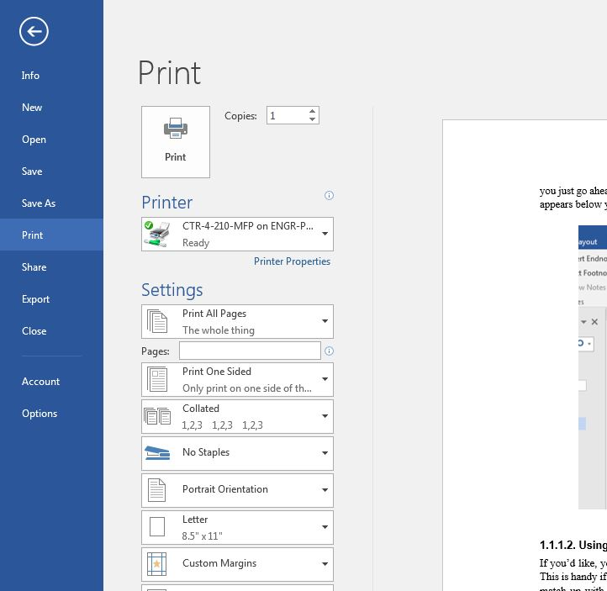

Figure 1.4 The print dialog box—escape hatch in the top left corner

#### Addressing Potential Auto-Linking Error Messages

Figure 1.5 is just an example figure. Here’s a fun experiment: delete Figure 1.5 and its caption, then update your fields and see what happens to the cross-reference that begins this paragraph.

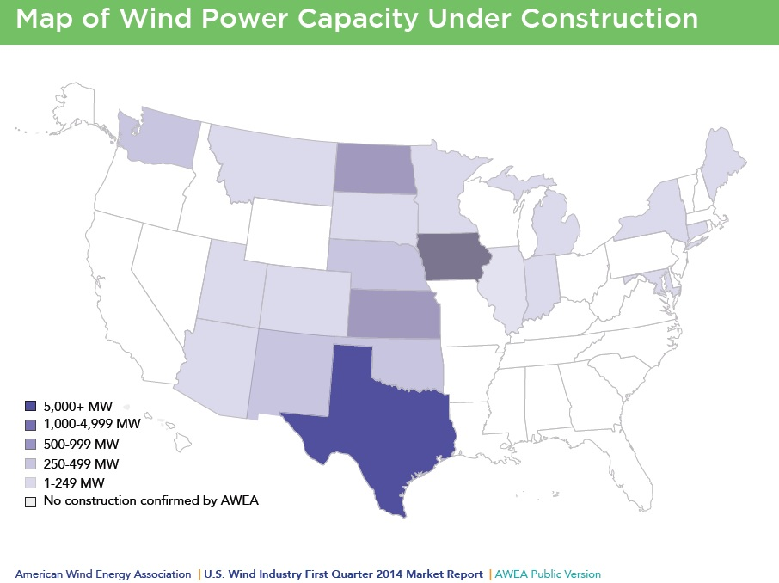

Source: image source

Figure 1.5 Example figure caption

## Styles Used in This Template

Listed below are the template styles in the order they appear in this document. The next chapter provides examples of all these styles in use.

* ctr DOT fields (used in the DOT form)
* ctr front matter title (used for the titles of front matter sections such as Disclaimers and Acknowledgements)
* Heading 1 (use this for your chapter titles to take advantage of the auto-numbering of Headings 2 through 6)
* Heading 2
* Heading 3
* Heading 4
* Heading 5
* ctr body text
* ctr figure caption
* ctr table title
* ctr bulleted list
  + ctr bulleted sublist
* ctr blockquote
* ctr back matter title
* ctr references listing
* ctr appendix subhead
* ctr figure caption (appendix)
* ctr table title (appendix)

## Margins and Such

We’ve set the margins at 1 inch on top and bottom and 1.5 on both right and left sides. The narrower columns make for easier reading online, where this document will eventually appear once it is approved for publication. If you need help accommodating larger figures and tables, please let us know.

Also, you’ll notice that our body text has no initial indent and no hard returns between paragraphs. All the main body text is styled as “ctr body text.”

## Need Help?

Contact Maureen Kelly in CTR’s Production Department:

[maureenk@mail.utexas.edu](mailto:maureenk@mail.utexas.edu) or 512.232.3128.

# Heading 1

The style used for paragraph blocks is ***ctr body text***. Lorem ipsum dolor sit amet, consectetur adipiscing elit, sed do eiusmod tempor incididunt ut labore et dolore magna aliqua. Ut enim ad minim veniam, quis nostrud exercitation ullamco laboris

## Heading 2

Lorem ipsum dolor sit amet, consectetur adipiscing elit, sed do eiusmod tempor incididunt ut labore et dolore magna aliqua. Ut enim ad minim veniam, quis nostrud exercitation ullamco laboris.

### Heading 3

Lorem ipsum dolor sit amet, consectetur adipiscing elit, sed do eiusmod tempor incididunt ut labore et dolore magna aliqua. Ut enim ad minim veniam, quis nostrud exercitation ullamco laboris. See Figure 2.1

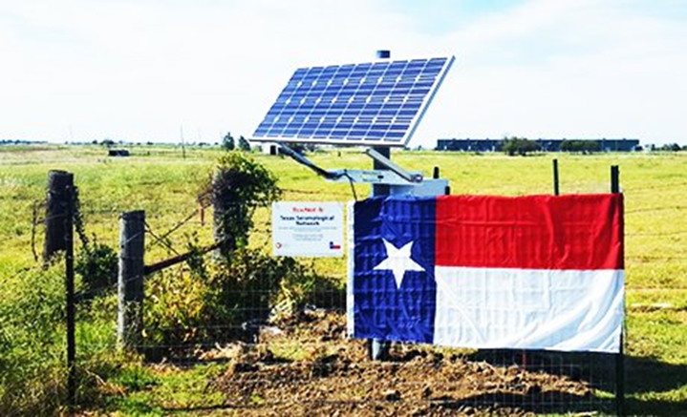

Source: ctr source

Figure 2.1 ctr figure caption

#### Heading 4

Lorem ipsum dolor sit amet, consectetur adipiscing elit, sed do eiusmod tempor incididunt ut labore et dolore magna aliqua. Ut enim ad minim veniam, quis nostrud exercitation.

##### Heading 5

Lorem ipsum dolor sit amet, consectetur adipiscing elit, sed do eiusmod tempor incididunt ut labore et dolore magna aliqua.

* This style is ***ctr bulleted list***
* ad
* minim
  + This style is ***ctr bulleted sublist***
  + quis nostrud
* exercitation
* ullamco

## Heading 2

Lorem ipsum dolor sit amet, consectetur adipiscing elit, sed do eiusmod tempor incididunt ut labore et dolore magna aliqua. See Table 2.1.

Table 2.1 ctr table title

|  |  |  |
| --- | --- | --- |
| **Class** | **WPD** | **Wind Speed (meter/second)** |
| 1 | 0–200 | 0.0 – 5.6 |
| 2 | 200–300 | 5.6 – 6.4 |
| 3 | 300–400 | 6.4 – 7.0 |
| 4 | 400–500 | 7.0 – 7.5 |

quis nostrud exercitation ullamco laboris nisi ut aliquip ex ea commodo consequat. Duis aute irure dolor

This style is ***ctr blockquote***. It has the required characteristics of a blockquote: indented on both sides and a smaller font. Lorem in voluptate velit esse cillum dolore eu fugiat nulla pariatur. Excepteur sint occaecat cupidatat non proident, sunt in culpa qui officia deserunt mollit anim id est laborum.

quis nostrud exercitation ullamco laboris nisi ut aliquip ex ea commodo consequat. Duis aute irure dolor

## Back Matter Styles

Finally, we have the back matter styles, which govern the appendices and references. These sections do not follow the numbering of the main body of the report, so they use a different style while giving a uniform appearance.

But first, a word (or a chapter) on accessibility and other required or suggested features.

# Get Your Work Read

An essential component of research is publication. Publication won’t get you far without distribution, however. Make sure your work is accessible by including your ORCID ID and meeting ADA guidelines for accessibility.

## Know and Use Your ORCID ID

ORCID is a nonprofit organization helping create a world in which all who participate in research, scholarship, and innovation are uniquely identified and connected to their contributions and affiliations, across disciplines, borders, and time. As of January 1, 2016, ORCIDs are required for researchers who must comply with the U.S. DOT Public Access Plan—this means you.

ORCID provides a persistent digital identifier that distinguishes you from every other researcher and, through integration in key research workflows such as manuscript and grant submission, supports automated linkages between you and your professional activities ensuring that your work is recognized.

On the DOT form (that very first page), provide the ORCID URL after each author name, when available.

* Example: Josiah Carberry, Ph.D. <http://orcid.org/0000-0002-1825-0097>

## ADA Guidelines

Documents that appear in our library need to comply with certain accessibility requirements, ensuring that readers with physical or visual impairments can read the publications. The library has an international customer base—researchers worldwide need to access your research. The benefits extend beyond our library: an ADA-compliant document is more easily findable to search engines and thus increases your readership.

An important first step is using the headings provided in this template. They are customized versions of the built-in Word settings, which are designed for accessibility compliance. That feature will carry over to the published PDF.

As of October 2020, we are working on a PowerPoint presentation to introduce researchers to accessibility principles and outline a few key steps. Please contact Maureen in CTR’s Production Department for the approved version of this PowerPoint.

References

This style is ***ctr references listing***. (2008) Lorem ipsum dolor sit amet, consectetur adipiscing elit, sed do eiusmod tempor incididunt ut labore et dolore magna aliqua.

American Wind Energy Association (2014) Lorem ipsum dolor sit amet, consectetur adipiscing elit, sed do eiusmod tempor incididunt ut labore et dolore magna aliqua.

Apergis, N., and Payne, J. E. (2010) Lorem ipsum dolor sit amet, consectetur adipiscing elit, sed do eiusmod tempor incididunt ut labore et dolore magna aliqua.

|  |
| --- |
| **Reminder:** the authors are responsible for ensuring references are properly formatted and cited, with a consistently applied format for both the references listings and the in-text cites.  If you need help correctly formatting your references, check out NoodleTools—a web-based student research service that helps you correctly cite sources in MLA, APA, and Chicago/Turabian citation styles. Use NoodleTools throughout a research project to track your sources, take notes, create outlines, collaborate with classmates, and format your references list.  Available through the UT Library System: <https://guides.lib.utexas.edu/citesources/noodletools> |

Appendix A. Landscape Example

This section is set up for landscape orientation.



Figure A.1 Here’s another sample figure.

Appendix B. Portrait Example

This appendix returns to the portrait orientation.

Appendix Subhead

The following table is manually numbered. I’m working on a way to create auto-numbered styles based on appendix numbering—Word is resistant so far to having two independently automated systems in one file. Stay tuned!

Table B1. Another sample table

|  |  |  |
| --- | --- | --- |
| **Variable** | **Coeff.** | **t-stat** |
| Constant | -6.116 | -0.83 |
| *GDPt,t-1* | 1.151 | 2.14 |
| *Dlinesq,t-Dlinesq,t-1* | -0.670 | -2.32 |
| Adjusted R square | 0.250 | |