Alternative Text
All figures and complex equations must have alternative text, commonly known as alt text.

Figures
Alt text for figures is typically 1–2 sentences and should express whatever the image was meant to convey.
Here are a few key considerations to keep in mind when writing alt text for figures:
- A good way to think of it is, what would you say to the audience if you were giving a presentation and this image didn’t load in the PowerPoint? Some examples:
  - If it’s a chart, they will want to know the specific steps or main points/numbers of the chart, rather than simply that it’s a chart.
  - If the image shows the reader how to do something, like use a particular function in an application, the alt text should also explain this, such as where on the screen they can find the function, and which option to select.
- Keep in mind when writing alt text that the caption will be read first, and the alt text should not be redundant to the caption.
- Rather than giving a detailed description, you can point to a specific section in the text if it interprets or explains the image.
- It make sense to note the kind of figure only if this affects how it will be interpreted and isn’t otherwise clear from the caption. For example, you might specify if an image of a road is a photograph or a map.
- If something is purely decorative, there is a checkbox where you can mark it as such.
For more information, here is a guide to alt text created by UTRGV: https://www.utrgv.edu/eolc/_files/2017/posters/handouts/a-guide-to-alternative-text.pdf.

Equations
Complex equations typically also require alternative text to be understandable to a screen reader, both conceptually and structurally, if they include math characters. However, as alt text can only be added to figures, this does require an extra step.
One option is to take a screenshot of the equation and then replace the equation text with the screenshot. Alt text can then be added as explained below. Alternately, there are some programs that can do this automatically (e.g., ExtendOffice.com), but we can’t vouch for their safety from malware or tracking.
Equation alt text example from the University of Central Florida:
This is the original equation as an image: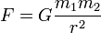 Alt text options:
- The force of gravity is proportional to the product of the two masses and inversely proportional to the square of the distance between them.
- F equals G times m sub 1 times m sub 2 over r squared, where F is the force between the masses, G is the gravitational constant, m1 is the first mass, m2 is the second mass, and r is the distance between the masses.
- F equals G times m sub 1 times m sub 2 over r squared.

Ways to add alt text
Adding Alt Text One Image at a Time in MS Word
Figure 2.1. Inserting alt text
To add alt text to each image individually, right-click on the image and scroll down to “Edit alt text,” fourth from the bottom. An alt text box will show up on the right column.
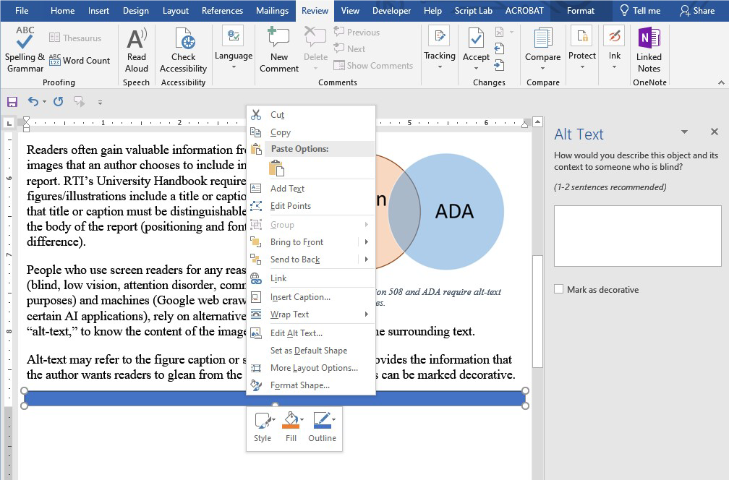

Adding Alt Text to All Images Consecutively
MS Word
If you’re adding alt text to all images at once, an easier way to do this is to select the “Check Accessibility” button on the left under the Review tab in the middle of the top banner. Then a box should open up in the right column with a list of all images missing alt text. You should be able to click on each one and add alt text.
Adobe Acrobat
On the righthand vertical toolbar, select the Accessibility button (a person in a circle). A larger toolbar will open up that includes the option “Set Alternate Text.”

